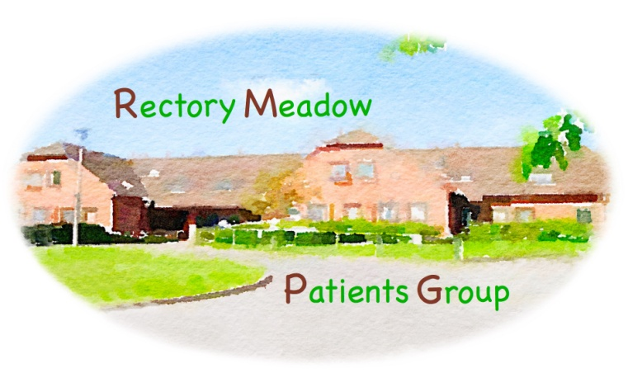
RECTORY MEADOW PATIENTS GROUP. Minutes–ZOOM.
General Meeting–15 February 2022 at14.00
Your Committee - Chris Purves, Liz Davidson, Ron Newall, Drene da Silva, Graham Cook, Roy Evans, Tony Burckhardt, Brian Eady, Simon Walker, Peter Mcloughlin, Mike Hender, Lyn Falkner, Fred Jennsand Gordon Barratt
Invitees – All members
Apologies – Ron Newell, Anne Hayden
Welcome to Fred Jenns a new member of the committee
General Meeting
- Minutes of 16thNovember 2021 approved
- Primary Care Network – update from Bobby Pozzini-Child – PCN Business Manager and Julie Dennis – Mental Health and Wellbeing manager.
- Comprehensive presentations from both speakers accompany minutes - very well received
- Covid vaccination programme – Bobby stated that RMS has very good recordwithin the mid Chiltern PCN - in December 2041 people were vaccinated in 1 week and RMS vaccinated 1000 of these. There are no plans to do additional clinics but would like to thank everyone for their support.However clinics are being set up to vaccinate vulnerable 5-11 year olds.
Q. Is there any evidence that these new services are reducing the GP pressure?
A.Difficult to measure impact as it will take time but expect to see measures put in place to show progress on effect on GP time such as less attendance at surgery by some patients.
Email for referral without going through a GP is mid-chiltern.socialprescribers@nhs.net
Q.When will the PCN start offering services as originally designed. i.e. 7days 8till8?
A.Currently working in line with Federation not the surgery so not sure but maybe by October we will see progress.

- Members experiences and recommendations:- Ongoing
- Appointments at Rectory Meadow surgery
Q.When are we likely to get online, on the day appointments – will they be starting up again?
A.We don’t know - currently they are suspended and there are still issues around COVID. Also there is no ability to triage incoming calls. Will be pursued.
Telephone/video consultations- RMS has telephone and video consultations.
The surgery has been requested to review the recorded message on the initial telephone response which is perceived as being too long
- Repeat prescriptions - There are issues around this subject some of which are with the pharmacies themselves. Tesco appears to have few problems.However Hobbs has problems in opening times (closed lunchtimes and weekends),is sometimes unable to supply a prescription in one go (meaning that patients have to go back again), has had missing items from repeat prescription and in one case had over-prescribed.Many people have been put on new eRD process but there has been no explanation or consultation as to how thisshould work– don’t know process in place. Surgery will be requested to clarify process and communication will be sent to PPG members.
Video explaining how process should work - https://youtu.be/zzaNeAaelAo
Fred Jenns will write to Tesco manager thanking him and his staff for their service.
- Nominating a pharmacy See linkhttps://www.nhs.uk/nhs-app/nhs-app-help-and-support/prescriptions-in-the-nhs-app/nominating-a-pharmacy/
- Covid Booster and Flu Vaccination appointments– Bobby stated that RMS has very good record within the Mid Chiltern PCN - in December 2041 people were vaccinated in 1 week and RMS vaccinated 1000 of these . There are no plans to do additional booster clinics but would like to thank everyone for their support. Clinics are being held to vaccinate vulnerable 5-11 year olds or those with immunosuppressed family members.
- Surgery news
- Position of Practice Manager –new practice manager promised for beginning of April – will update at May general meeting .
- Staff shortages - There are still staff shortages but other changes for staff roles are in progress to cover the work.
- We now have 1141members including new members recruited during the COVID clinics. We have 70 volunteers who have offered to support various initiatives in the practice.
- Blood test clinics are no longer run routinely as before at surgery.Want to encourage people who can to go to a hospital for a blood test.
Q. Where we can get a blood test done? A. Amersham or another hospital
Q. What is advice on the procedure for arranging a blood test? A. Cannotself refer for a blood test must be via GP surgery
Q. If you refer yourself for a blood test, how does the phlebotomist know which specific tests are required? A. Again would be through the surgery
- Health Awareness Events
- Future events – potential topic ‘How digital technology will change/impact management of NHS and surgery’. Still attempting to get a speaker for this subject – may have to be delayed or replaced with another topic
- A proposal made to address the issue “Action on autism” which is on the rise and where there is not enough recognition. Possible in Autumn
- Potential for event on loss of sight.
- Newsletter status–Update – in abeyance to discuss with RMS when have a new Practice Manager
- Website –Update– surgery are looking to allocate somebody to the task of updating the surgery website. PPG has requested that the link to PPG items be given prominence on the home page instead of buried behind ‘Have your Say’.
- AOB.
- Election of committee members – scheduled for May AGM
- Possible invite to clinical pharmacist for next general meeting
- To note that on 2nd July in Wycombe there will be a free blood test availablebetween 10.00-13.00 for detecting prostate cancer. Full details of the session and how to book will be forwarded to all RMS PPG members nearer the time.

NOTE: We will continue to have ZOOM meeting during this period – it is too early to consider face to face meetings and a venue would need to arise.

Date of next AGM &General Meeting – 17th May 2021 at 14.00

