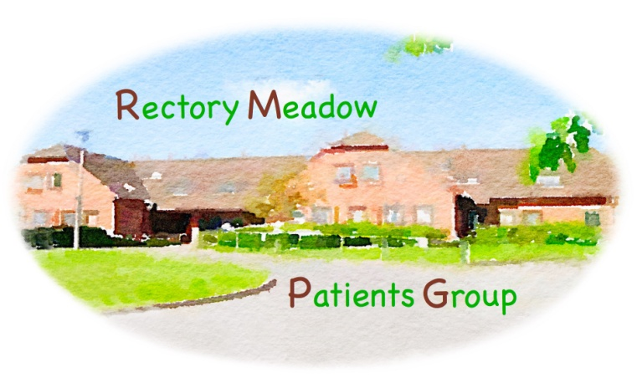
RECTORY MEADOW PATIENTS GROUP.
MINUTES – General Meeting -15 August 2023
Your Committee - Chris Purves, Mike Wort, Liz Davidson, Ron Newall, Drene da Silva, Graham Cook, Tony Burckhardt, Simon Walker, Peter Mcloughlin, Mike Hender, Fred Jenns and Gordon Barratt
Chair welcomed Mike Wort
Apologies for absence – 5
31 members attended
The minutes of the General Meeting held 16 May 2023 were approved
IMPORTANT – Please read the following in conjunction with the relevant slides. These contain a significant amount of relevant information

- Surgery news – Update from Debbie Ratu
Refer slides 3-12
- Staff and patient surveys both good – will look at detailed comments over next month
- Currently fully staffed
- New Paediatric Nurse commences September – Ben Stock.
- New GP trainees are Mariana Ferrari Barbosa and Sri (Sriharsha) Yatham
- New website will be launched 25th August – slides 4-6
- New phone system – soft launch date 2nd October – TBC.
- NHS satisfaction survey. RMS – top in PCN – 2nd in Bucks
- Patient numbers are now 10,541
- Doctor’s lists – to be distributed to include new salaried GPs from September.
- NHS App usage – slide 7
- Incoming calls – slide 8
- Statistics and Survey – slide 9
- RMS Practice population – slide 10
- Appointment Statistics – slide 11
- NHS GP Survey 2023 – slide 12

- RMS Patient Survey 2023 – slides 13-14
- Updates - Primary care network – slides 15-16
- Health Awareness Events
Planning cancer related meeting in the Autumn

- A.O.B.
Date of next Committee meeting - Tuesday 7 November 2023 at 10.00

Date of next General Meeting – Tuesday 21 November 2023 at 14.00

