

Inside this Issue

CQC result is in!

Spring Covid-19 boosters

Latest update direct from our PPG

Afternoon Closures
The Surgery will be closed for Staff Training from 1300:
Tues 17th March 26
Tues 14th April 26
Weds 13th May 26
Thu 18th June 26
Wed 15th July 26
Tues 15th September 26
Thu 15th October 26
Tue 17th November 26
Wed 13th January 27
Thu 11th February 27
Tue 16th March 27

If you need medical advice while the Surgery is closed, please call 111 or 999 if you need urgent care.

Missed
Appointments

Last quarter we had 150
patients who missed their appointments and didn’t inform us.
This is a is a big increase on the last quarter. This costs the NHS approximately £6000! It is very important that you let us know if you are unable to attend your appointment so that we may offer it to someone else
needs it by calling the Surgery or emailing us at rectorymeadowsurgery@nhs.net

Rectory Meadow Surgery
Newsletter – Spring 2026
Welcome to our Spring Newsletter



Latest News

Rectory Meadow Surgery’s recent CQC result

On the 13th November 2025, Rectory Meadow Surgery had its first CQC inspection in almost 10

Years and we are proud to announce that we acquired a rating of “Good” overall.

The full report can be found online via the Care Quality Commission website here

Rectory Meadow Surgery - Care Quality Commission or by visiting our website. Please see the

overview below.

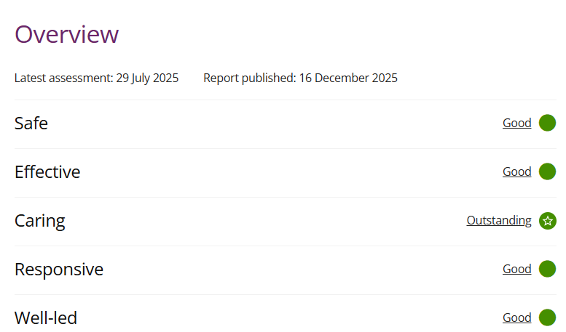

New GP Starting

We are pleased to announce that we have a new GP joining Rectory Meadow Surgery as a permanent staff member, her name is Dr Yasmin Nunwa and we know she will be a wonderful asset to the team. We hope you will welcome warmly.

What is Health and

What is health and Wellbeing Coaching?

Health and Wellbeing Coaches support patients by empowering them to become more confident at managing their own health. The Coaches do not give advice; however, they use a holistic approach to develop the knowledge and confidence of patients through increasing motivation and promoting behavioural change. There is the opportunity to attend Group sessions on areas such as Gut Health, Cholesterol, Hypertension and general Health and Wellbeing. These sessions are held monthly, there’s also the option to have one to one sessions. The focus is on healthy eating, physical activity, weight management for patients who have a pre-existing condition, sleep and mental wellbeing. They support the self-management of long-term conditions e.g. hypertension, diabetes, heart disease etc. To register your interest, please go the Mid-Chiltern PCN website and complete the self-registration form.

Social Prescribing - Mid Chiltern PCN


Pharmacy First service:

In the UK, Pharmacists can provide advice and where appropriate, prescribe treatments for Hayfever without a GP visit.

For spring hay fever, pharmacists advise starting preparations 2-4 weeks before symptoms usually begin, typically around late February or early March for tree pollen. The core advice is to combine daily, non-drowsy medication barrier methods to prevent pollen entering the nose and eyes.

Preventative nasal sprays such Flixonase, Beconase – most effective 2-4 weeks before season begins

Antihistamines non-drowsy once-a-day tablets such as Cetirizine, Loratadine or fexofenadine

Eye drops such as Sodium cromoglicate

Barrier balms

Contact a GP if symptoms are severe, include wheezing or breathlessness or do not improve with over-the-counter medication. Hay fever - NHS
A warming word from our PPG

We have asked our patient group members to contribute to the newsletter with topics they feel have had experience with and would like to share with you.

‘Our Poor Feet’.

Foot pain is commonly caused by improper footwear which often results in conditions such as plantar fasciitis (heel pain) and Achilles tendonitis. Other common causes of foot pain include arthritis, gout, infections (athlete’s foot), or structural issues like bunions and high arches. All of these can lead to a poorer quality of life and frailty, particularly in the elderly.

It is so important to take care of our feet to prevent many feet related conditions. This is particularly important for patients with diabetes or chronic health issues. Daily inspection to check for cuts, sores or blisters, especially between the toes can prevent fungal infections developing. Use cream to keep skin soft and prevent cracking but avoid applying cream between toes. You should seek professional help for any persistent pain, corns or ingrowing nails. Avoiding uneven surfaces can also be a way of preventing injury.

Neighbourhood working is at the heart of how partners in Buckinghamshire will work together to help people to lead healthier more independent lives and deliver the Buckinghamshire Health and Wellbeing Strategy.

The county is being organised into six local ‘neighbourhoods’, where organisations can plan and deliver services together in a way that reflects the needs of local communities.

Each neighbourhood brings together representatives from the Council, General Practice, acute services, community services, the Integrated Care Board, Healthwatch, community pharmacy, mental health services the voluntary and community sector. By working together locally, these teams will focus on better joining up services, improving support closer to home, and helping people stay well for longer. Buckinghamshire Joint Local Health and Wellbeing Strategy 2035 | Buckinghamshire Council

