
Rectory Meadow Surgery
Newsletter – Summer 2025
Welcome to our Summer Newsletter

Inside this Issue

Afternoon Closures
The Surgery will be closed for Staff Training from 1300:
18th September
15th October
18th November
15th January
11th February
17th March

If you need medical advice while the Surgery is closed, please call 111 or 999 if you need urgent care.

Missed
Appointments
It is very important that you let us know if you are unable to attend your appointment so that we may offer it to someone else.
Last quarter we had 179 patients who missed their appointments and didn’t inform us.
This is a huge improvement on the previous quarter and so thank you to everyone who attended or cancelled.



Latest News

Changes to Childhood Vaccination Schedules

Please see this below link to the changes to the schedule for children’s immunisations.

Changes to the routine childhood vaccination schedule from 1 July 2025 and 1 January 2026 letter - GOV.UK

Measles and The Importance of Vaccination

Measles is highly contagious, so even a small decline in MMR uptake can lead to a rise in cases. In 2024 there were 2,911 laboratory confirmed measles cases in England, the highest number of cases recorded annually since 2012. Most of these cases were in unvaccinated children under the age of 10 – If your child/children have not received the MMR vaccine, please contact the surgery to arrange an appointment. More information on the rise of measles within the UK for 2025 can be found by clicking on the following link:

Confirmed cases of measles in England by month, age, region and upper-tier local authority: 2025 - GOV.UK

Changes to Cervical Screening Intervals

Cervical screening intervals are changing in England. From July 1, 2025, women and people with a cervix aged 25-49 who test negative for HPV (Human Papillomavirus) will be invited for screening every 5 years instead of every 3 years. This change is based on evidence that HPV primary screening is more accurate and that those with a negative HPV test are at very low risk of developing cervical cancer in the next 10 years.

Introduction to the New Health Segmentation Scoring

You may notice a test result appear in your NHS APP referring to “segmentation” or “Johns Hopkins Adjusted Clinical Groups (ACG) system score”.

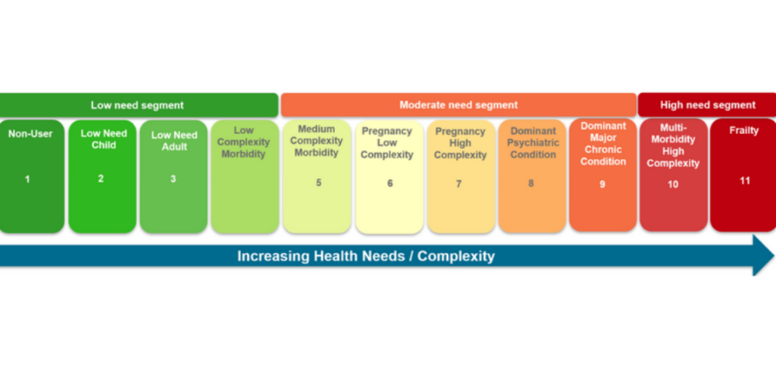
Segmentation/Johns Hopkins Adjusted Clinical Groups (ACG) system score is a simple way of categorising patients based on their specific health needs. It helps us as a practice understand the individual needs of our patients based on their health and wellbeing to support personalised care and ensures you get the right support in a timely way. Please see example of scoring below.

Hot topics from our PPG

We have asked our patient group members to contribute to the newsletter with topics they feel have had experience with and would like to share with you.

Summer Safety

We expect some warm weather in July and August and sometimes in September known as an ‘Indian summer’. It’s been an exceptionally warm season; we would encourage everyone to apply high factor sunscreen even if the sun is not out at the time as it’s the UV (ultraviolet) radiation that is so damaging to the skin of all ages and skin types. Please stay hydrated, look after young and old relatives and follow her for more healthy summer tips! Heatwave: how to cope in hot weather - NHS

Shingles Awareness

What has the "creeping snake or growing snake," from Chinese legend to do with the “belt of red roses from Hell, “which comes from medieval England, have in common? Both refer to what we now know as shingles. There is now an effective vaccine available for those eligible to receive it.
The reason for the subject is somewhat personal as I was struck down by the wretched shingles 35 years ago and had no idea what it was except it was extremely painful. My husband and I travelled to our home in France and for two days I put up with the pain in my back. We eventually called a Doctor, and I then spent 10 days in hospital on a drip. Whenever I get tired or stressed the feeling returns in my left leg so if I can persuade one person to have the vaccine that is now available and avoid shingles, I will be a happy soul!

Until the next newsletter, stay safe and take care of yourselves - Jules

Patient Survey 2025

It’s the time of year again when we would like to get the views of Rectory Meadow patients on the services provided to enable us, in conjunction with the Practice to find ways to develop and improve in the future. Some of the questions are repeated so that we have a year-on-year comparison and some are new to reflect the changing environment. Your feedback by answering our short survey will enable us to learn from our collective experiences and plan for a sustainable future. You may receive a text from the surgery - also inviting you to participate in the survey. Please only submit one response per person. The Survey can be accessed by clicking on the link below: https://s.surveyplanet.com/st8vxuxt

