# 

# Adjusted Clinical Groups (ACG) Patient Need Groups (PNG): What are they and how are they used in Healthcare?

## What are the Johns Hopkins Patient Need Groups (PNG)?

The Johns Hopkins Adjusted Clinical Groups (ACG®) System is a comprehensive population health analytics solution that transforms data that exists in primary and secondary care records into a series of meaningful patient-level and patient-centric indicators.

PNGs categorise patients into different groups based on the complexity and intensity of their healthcare needs rather than just their medical conditions. Instead of focusing solely on a diagnosis (like diabetes or heart disease) PNG takes in to account a broader range of health characteristics about a patient.

### Adjusted Clinical Groups (ACG) Patient Need Groups (PNG)

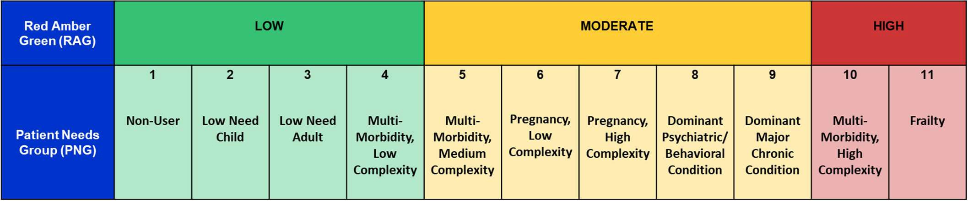

## How do PNGs work?

These groups consider factors like the number of chronic conditions, the severity of illness and the level of support a patient might need.

The patients in a particular group have similar patterns of need. As the PNG increased the patient health needs similarly increase.

For example:

* Red (High) PNG 10,11 = Complex Care Needs: Patients with multiple chronic conditions, requiring regular monitoring and a coordinated care approach.
* Amber (Moderate) PNG 5-9 = Stable Chronic Conditions: Patients with chronic conditions that are well-managed and require occasional support to maintain their stability.
* Green (Low) PNG 1-4 = Healthy: Patients without significant health issues who could benefit from preventive care.

As patient needs change over time, their PNG categorisation changes with them. PNG offers an at-a-glance indication of a patient’s broader needs, **at a point in time**.

## What are the benefits of having this information (PNG) available on patient records?

1. **Personalised Care**: Healthcare providers can use PNGs to tailor their care plans. This means patients receive the specific type of care they need, whether it’s more frequent monitoring, specialised treatment, or preventive care.
2. **Improved Coordination**: PNGs help healthcare teams coordinate more effectively. If a patient has complex needs, the care team can work together to ensure all aspects of their health are addressed, from medication management to lifestyle support.
3. **Better Resource Allocation**: Hospitals and GP Surgeries can allocate resources more efficiently based on the needs of different patient groups. This ensures that patients with the most urgent needs receive timely care, while those with less critical conditions are managed appropriately.
4. **Proactive Health Management**: For patients in lower-need groups, PNGs encourage preventive care and early intervention. This can help them maintain their health status and avoid complications in the future.
5. **Enhanced Communication**: PNGs facilitate better communication between patients and healthcare providers. By understanding which group a patient falls into, together they can have clearer discussions about what to expect from the care they receive and what actions they can take to manage their health.

## Where will I see my PNG?

Your PNG will be displayed as a Test Result in the NHS APP. Your PNG value may change over time - see example (note the final implementation may be slightly different from that shown).

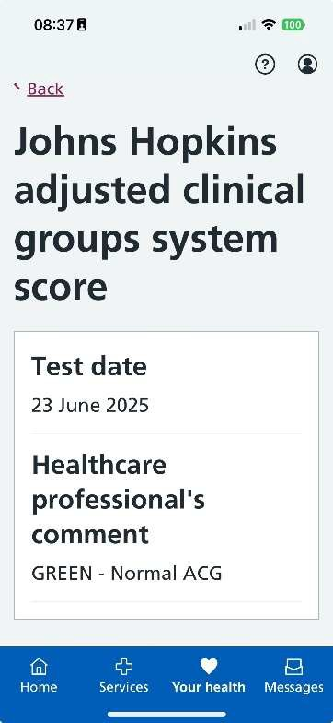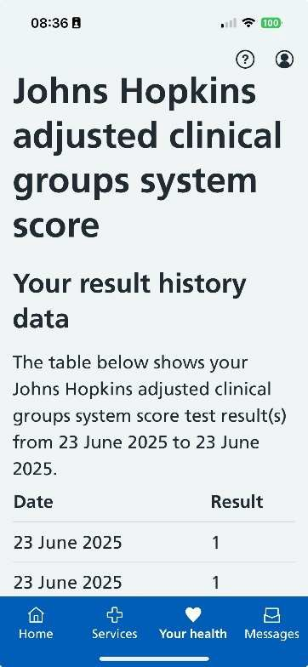

## Frequently Asked Questions

### Johns Hopkin University Score Validation

The score from Johns Hopkins University that appears on your medical record is part of a national initiative designed to enhance our practice’s understanding of patient group needs. There is no cause for concern regarding this score. The system was developed by Johns Hopkins University, which is renowned for its contributions to advancing medical practices and healthcare systems globally.

### Johns Hopkin University Score - Social Media

Understanding the Johns Hopkins University Adjusted Clinical Needs (ACNs) score and Patients Need Groups (PNGs).

Ever wondered how healthcare providers tailor their care?

Introducing Patients Need Group(s) (PNGs) from Johns Hopkins University.

What are PNGs? PNGs categorise patients based on the complexity of their healthcare needs, not just their medical conditions.

How do they work? Patients are grouped by factors like chronic conditions and severity of illness:

* Group 1 PNG (Green): Requires less intervention
* Group 2 PNG (Amber): Stable Chronic Conditions
* Group 3 PNG (Red): Complex Care Need Benefits:

1. Personalised Care
2. Improved Coordination
3. Better Resource Allocation
4. Proactive Health Management
5. Enhanced Communication

This is just one of several indicators/tools that are used in primary care to get a full picture of patient needs.

More information see: https://[www.edlesboroughsurgery.co.uk/2025/04/15/segmentation-patient-needs-](http://www.edlesboroughsurgery.co.uk/2025/04/15/segmentation-patient-needs-) group-png/

Patient Need Groups (PNGs) categorise patients into different groups based on the complexity and intensity of their healthcare needs rather than just their medical conditions. See: https://[www.hopkinsacg.org/wp-content/uploads/2022/08/Johns-Hopkins-ACG-System_v13.0_PNG-](http://www.hopkinsacg.org/wp-content/uploads/2022/08/Johns-Hopkins-ACG-System_v13.0_PNG-) Overview-v080322.pdf

### Patient Experience – Patient Needs Group (PNG) Score (Test) Result appears in the NHS APP

Patients may notice a test result appear in their NHS APP referring to segmentation or Johns Hopkins Adjusted Clinical Groups (ACG) system score.

Segmentation is a simple way to categorise patients based on their specific health needs. It helps us as a practice understand the individual needs of our patients based on their health and wellbeing to support personalised care and ensures you get the right support in a timely way

### Updating Patient Need Group(s) (PNG)

Currently the information is uploaded to the clinical system monthly. In the future this manual process will be replaced by automation (known as an Application Specific Interface (API)) between the Connected Care database & Clinical System (EMIS). Most patients PNG value will remain the same from month to month, however, be aware for now that a recent event such as a stroke may not alter the value straight away.

It follows that for a given medical presentation such as a suspected urinary tract infection (UTI) those in the Green PNG may be more suitable for referral to the Community Pharmacist Consultation Service (CPCS) (also known as Pharmacy First) than those in the Amber or Red PNGs. This may result in fewer CPCS referrals being returned to the surgery. Those in the Amber PNG need effective continuity of care as do those in the Red PNG although the latter may be under the watchful eye(s) of the Integrated Care Team (ICT).

### Patient does NOT use / have the NHS APP (WEB NHS APP)

Patients without the NHS APP will be oblivious of their PNG ‘score’ however, it will be used to manage their healthcare needs.

### Patient Confidentiality

All patient data including PNG is maintained confidentially within the Patient Management System and used solely for healthcare management.